Patient information leaflet or her legal representative

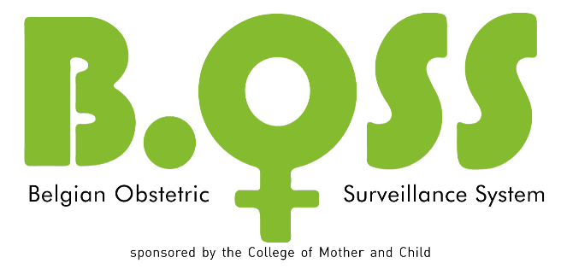

Dear Madam,

Your obstetrician gave you this information leaflet, because you recently experienced a serious complication during your pregnancy or childbirth.
Currently this serious complication is under investigation by the Belgian Obstetric Surveillance System (B.OSS). The aim of this B.OSS study is to better understand this complication, which only occurs very rarely. By improving our knowledge, we want to provide better information and better care to future expectant mothers in Belgium.

Therefore, including the details of your specific case in this B.OSS investigation is extremely important. You will find detailed information on the study in this information leaflet. For more information you can further visit the website www.b-oss.be. Do you still have questions after reading this information? Please contact the B.OSS research team: you will find contact details at the end of this letter.

Background and purpose of the study
In our Western world, most women have a happy and successful pregnancy without any problems. Only a small number of women will develop a minor complication during pregnancy or childbirth. And even more rarely a woman will suffer a serious complication, that requires an emergency intervention to save her and / or her baby’s life.

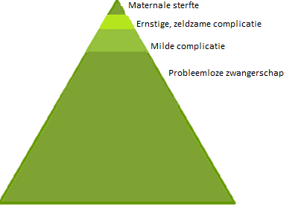

These serious complications are so rare, making them difficult to investigate. As a result, we have no hard evidence on how frequent they occur, on strategies to prevent them or the best way to manage these complications.
By registering all cases of this complication that occurred in a larger region – Belgium in this case - and by analysing the details of these cases, we can improve our knowledge. Better knowledge in turn will improve the information we can provide to our mothers and will further improve our quality of care. The United Kingdom was a pioneer in this area with the United Kingdom Obstetric Surveillance System (UKOSS) started up in 2005 and they demonstrated that UKOSS-studies contributed efficaciously to improved care for pregnant women and their babies.
The Belgian Obstetric Surveillance System (B.OSS) was launched in 2011 with the support of the College of Physicians for Mother and Newborn of the Federal Public Service Public Health.
With the data retrieved by B.OSS, we are able to compare the obstetric care in Belgium with the care in our neighboring countries, hence develop and improve Belgian guidelines.

What is being investigated?

B.OSS investigates serious complications that occur during pregnancy or childbirth and that put the life of the mother and/or the unborn child at risk. These are rare complications that affect less than one out of 2,000 women.

These studies already have been completed:
- Uterine rupture
- Peripartum hysterectomy and embolisation (removal of the uterus or closure of the blood vessels of the uterus due to a heavy bleeding)
- Eclampsia (convulsions during pregnancy or after delivery due to pregnancy poisoning)
- Antenatal pulmonary embolism
- Spontaneous hemoperitoneum in pregnancy (spontaneous bleeding in the abdomen during pregnancy, not due to trauma or due to uterine rupture)
- Anaphylaxis during pregnancy (serious allergic reaction)
This study is currently running:
- Intrahepatic Cholestasis in pregnancy (a potentially serious liver disorder in which the normal flow of bile is affected)
- COVID-19 infection in pregnancy

You can always find an update on the website www.b-oss.be.

Which data are collected?

By sending a monthly email to the B.OSS-investigator in every Belgian maternity unit, we determine how frequent this complication occurs in our country.

Further, we analyse every reported case based on the information provided by the obstetrician. Therefore, the obstetrician needs to complete a questionnaire, requesting the following details available in the medical notes:
- general data on age, weight and height, ethnic origin, occupation, smoking status
- medical and surgical history
- relevant family history
- the course of previous pregnancies
- the course of this pregnancy
- the circumstances and the course of the complication
- the management of the complication
- the outcome for the mother
- the outcome for the baby

Ethical committee approval

The B.OSS study is approved by the Ethics Committee of the UZ Ghent as a central ethics committee (EC UZG 2015/1470, B670201526875). Further, the study is approved by the local ethics committee of the hospital where you were admitted. The study is conducted in accordance with the guidelines of good clinical practice (ICH/GCP) and the Helsinki Declaration, written to protect those involved in clinical studies.

Permission

If you agree to include the data of your pregnancy and childbirth in this B.OSS study, we ask you to sign the consent form together with your obstetrician. You will find this form at the end of this leaflet.
You do not need to take any further action yourself to participate in the study. If you agree, your obstetrician will pass the relevant data from your file pseudonymously to the research team by completing the questionnaire. This means that no data will be passed on to which you can be recognized; no identifiable information related to your person (no name, no date of birth, no place of residence, no file number).

What happens if you do not wish to participate in this study?

In case you would prefer your data not to be included in the B.OSS study, you simply notify your wish to your obstetrician. This will not affect in any way your further treatment, the follow-up or the relationship with your obstetrician or other health care providers.

What happens to the data?

The pseudonymised data are collected in a secured database. At the end of the registration period the data will be processed and analysed by the B.OSS research team. With this study we want to investigate the incidence of this pregnancy complication, the diagnosis and management in Belgian hospitals and the maternal and fetal outcomes of pregnancies complicated with ICP. Further, we want to compare Belgian incidence, management and outcome of ICP with our neighbouring countries.
When the data analysis is completed, the database will be kept for 20 years on the secured server of the UZ Ghent.
Because we can learn more out of international comparisons, B.OSS is part of the International Network of Obstetric Survey System (INOSS). The INOSS network enables the realisation of international studies. It is possible that the B.OSS - data are transferred to another research team within INOSS to contribute to an international comparative study.

Confidentiality

In accordance with the Belgian law of August 22, 2002, relating to the rights of the patient, the General Data Protection Regulation (or GDPR) (EU) 2016/679 of April 27, 2016 (that is in force since May 25, 2018) and the Belgian law of July 30 2018, on the protection of individuals related to the processing of personal data and on the free movement of such data your privacy will be respected and you can have access to the collected data if you want. Each error can be corrected at your request.
If you consent to participate in this study, we will process your data in accordance with the purpose of the clinical study. This processing of data is provided by law on the basis of Article 6, § 1, (b), (e) or (f) and Article 9, § 2 (j) of the General Data Protection Regulation.

All information collected during this study will be pseudonymised. Only pseudonymised data will be used for analysis and in any type of documentation, reports or publications (in the medical scientific literature and/or at medical conferences) concerning this study. Therefore, confidentiality of the data will always be guaranteed.
The controller of the data is the principal investigator of the study, Dr. Griet Vandenberghe. In the context of data protection, the data will only be processed by personnel belonging to the research team and designated by and under the responsibility of the principal investigator, including internal employees with a non-healthcare profession.
Data from the patient file are processed in the context of improvement processes of the organization and health care in general.

If you wish, the Data Protection Officer can provide you with more information about the protection of your personal data. Please contact Katya Van Driessche, dpo@uzgent.be.

Representatives of the promoter, auditors, the Medical Ethics Committee and the competent authorities, all bound by professional secrecy, can have direct access to your medical records under the responsibility of the investigator in order to check the study procedures and/or the data, without violating its confidentiality. This is only possible within the limits of the relevant laws. By signing this consent form and having received the preliminary explanations, you consent to this access.

The Belgian supervisory Data Protection Authority responsible for enforcing data protection legislation can be reached via the following contact details:

Data Protection Authority (DPA)
Rue de la Presse 35 – 1000 Brussels
Tel: +32 2 274 48 00
E-mail: contact@apd-gba.be
Website: www.dataprotectionauthority.be

Questions?

If you have further questions regarding this study, please don’t hesitate to discuss them with your obstetrician. You can also contact the B.OSS research team via:

Karolien.Benoit@b-oss.be
Griet.Vandenberghe@b-oss.be

Many thanks for your time to read this information leaflet and for your contribution to B.OSS.
We wish you all the best and a quick and full recovery.

Warm regards
The B.OSS research team

Consent Form

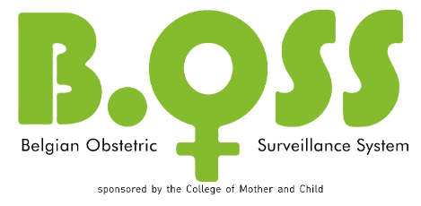

Tick by the participant if you agree

I have read and understood the document “Information sheet for the participants” page 1 to page 5 and I have received a copy of this document. I have been informed of the nature of the study, its purpose, its duration and what is expected of me.
I agree to participate in the study.
I understand that participation in the study is voluntary and that I can withdraw from the study at any time without giving a reason for this decision and without this having any influence on my further treatment.
I am aware that this study has been approved by an independent Medical Ethics Committee at UZ Gent and Ghent University and that this study will be conducted according to the guidelines for good clinical practice (ICH/GCP) and the declaration of Helsinki, designed to protect people participating in experiments. This approval should under no circumstances be taken as an incentive to participate in this study.
I have been informed that my data are processed and stored for at least 20 years. I agree and am aware that I am entitled to access and correct this information. As this data is processed for medical-scientific purposes, I understand that access to my data may be postponed until after the end of the study. If I want access to my data, I will address the doctor-investigator who is responsible for the processing of the data.

Name and first name of the participant | Signature | Date
Name and first name investigator | Signature | Date
2 copies must be completed. The original is kept by the investigator in the hospital for a period of 20 years, the copy is given to the participant.

* Tick by the investigator if you agree

I declare that I have provided the necessary information regarding this study (the nature, the purpose, and the foreseeable effects) orally and a copy of the information document to the participant.
I confirm that no pressure has been exerted on the participant to allow him/her to participate in the study and I am prepared to answer any additional questions.

